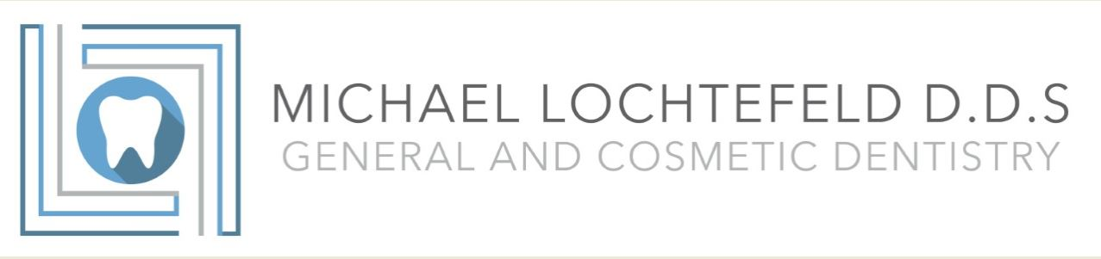

Appointment Cancellation Policy
We pride ourselves in providing extra time for the personal attention each patient deserves. We respect your time and make every effort to keep you from waiting. As a result, your appointment time in this office is reserved exclusively for you. We reserve the right to charge patients who do not reschedule with adequate notice, or who fail to keep their scheduled appointments.

How to Cancel Your Appointment
In order to be respectful towards all the needs of all Dayton Comprehensive Dentistry patients, if it is necessary to cancel your reserved appointment we require that you contact our office in 24 hours in advance. Appointments are in high demand and your early cancellation will give another person the possibility to access timely dental care. To cancel an appointment, please call 937-435-1353 to speak with an office representative. If you do not reach an office representative, you may leave a detailed message on the office voicemail. You may not cancel a scheduled appointment via email.

No Show Policy
A “no show” appointment occurs when a patient misses an appointment without canceling 24 hours in advance. No shows inconvenience patients who need access to dental care in a timely manner. Last minute/late cancellations are considered “no show” appointments. Failure to be present at the time of reserved appointment will result in a $50 fee. Exceptions to this policy must be approved by the Office Manager. By signing below I certify that I have read and understand the terms and conditions of Dayton Comprehensive Dentistry appointment cancellation policy:
Patient Signature: Date:

X_____________________________________________________________________________

