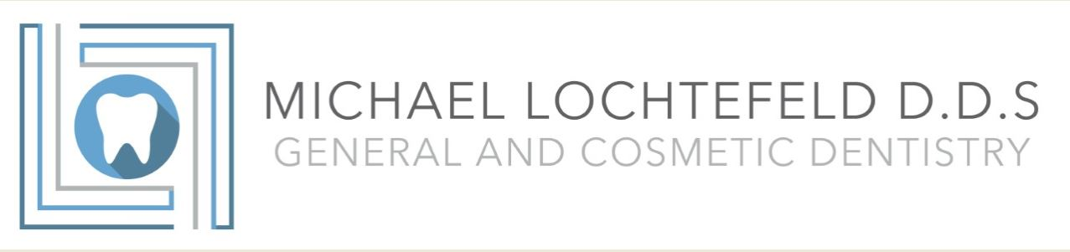

How did you hear about our office?

- Referred by a current patient :_______________________________________
- Insurance
- Drive- by
- Mailer
- Internet search
- Other:________________________________________________________________

What is the main reason for today’s visit?
__________________________________________________________________________________
__________________________________________________________________________________

Do you grind or clench your teeth? Yes No

Are you happy with: the size and shape of your teeth? Yes No

Are you happy with the color of your teeth? Yes No

Are you happy with the way you bite? Yes No

Do you have any concerns about crowding/spacing of teeth? Yes No

Do you have any other concerns?

